Hi, everyone~

안녕！`(*∩_∩*)′

At the beginning, we need to learn something about the TONE~

Since the syllables are limited, we need tones to differentiate the meanings~

╮(￣▽￣”)╭Let’s start !

BASIC KNOWLEDGE ABOUT TONES~

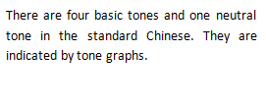

Like this~

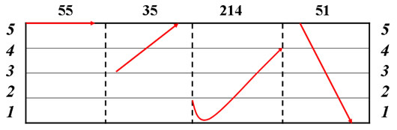

BASIC RULES FOR CHINESE TONES~

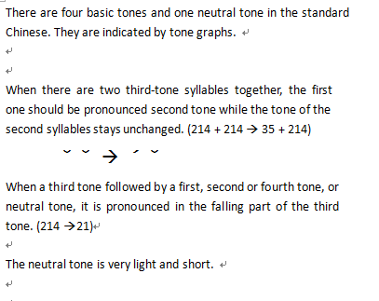

Now what you need to do is practice, practice, and practice!!!